**Innovative Product Development-2 AUTOMATIC IRRIGATION SYSTEM**

An Innovative Product Development-2 report submitted in partial fulfillment of the requirements for the degree of Bachelor of Technology in Information Technology

## by

## Police Bhavani Reddy 20RH1A12E5

## Nazreen Fathima 20RH1A12C6

## Madhu Priya 20RH1A12D1

### Under the Esteemed Guidance of

## Mr. KUMARA SWAMY

## Assistant Professor

Department Of Information Technology



MALLA REDDY ENGINEERING COLLEGE FOR WOMEN

**Autonomous Institution, UGC, Govt. of India Accredited by NBA & NAAC with an ‘A’ Grade** NIRF Indian Ranking, Accepted by MHRD, Govt. of India

Band-A (6-25th) National Ranking by ARIIA, Accepted by MHRD, Govt. of India Affiliated to JNTUH, Approved by AICTE, ISO 9001:2015 Certified Institution Maisammaguda, Dullapally(post), Secunderabad , TELANGANA

APRIL, 2023

MALLA REDDY ENGINEERING COLLEGE FOR WOMEN

## Autonomous Institution, UGC, Govt. of India Accredited by NBA & NAAC with an ‘A’ Grade

NIRF Indian Ranking, Accepted by MHRD, Govt. of India Affiliated to JNTUH, Approved by AICTE, ISO

9001:2015 Certified Institution

Maisammaguda, Dullapally(post), Secunderabad , TELANGANA

**DEPARTMENT OF INFORMATION TECHNOLOGY CERTIFICATE**

This is to certify that the Innovative Product Development-2 work embodies in this dissertation entitled “**AUTOMATIC IRRIGATION SYSTEM**” being submitted by Bhavani**(20RH1A12E5), MadhuPriya(20RH1A12D1), Nazreen Fathima(20RH1A12C6)** for partial fulfillment of the requirement for the award of degree of **BACHELOR OF TECHNOLOGY** in Information Technology, Malla Reddy Engineering College for Women (Autonomous), Maisammaguda, Secunderabad during the academic year 2022-2023.

**Guide Head of the Department**

**External Examiner**



MALLA REDDY ENGINEERING COLLEGE FOR WOMEN

## Autonomous Institution, UGC, Govt. of India Accredited by NBA & NAAC with an ‘A’ Grade

NIRF Indian Ranking, Accepted by MHRD, Govt. of India Affiliated to JNTUH, Approved by AICTE, ISO 9001:2015 Certified Institution

Maisammaguda, Dullapally(post), Secunderabad, TELANGANA

**DEPARTMENT OF INFORMATION TECHNOLOGY**

## DECLARATION

We ‘**Bhavani Reddy(20RH1A2E5), Madhupriya(20RH1A12D1), Nazreen Fathima(20RH1A12C6)’** are students of “**Bachelor of Technology in Information Technology**”, Malla Reddy Engineering College for Women (Autonomous), Maisammaguda, Secunderabad, hereby declare that the work presented in this project work entitled **“Automatic Irrigation System”** outcome of our own bona fide work and is correct to the best of our knowledge and this work has been undertaken taking care of Engineering Ethics, submitted to **MallaReddy Engineering College for Women (UGC-Autonomous),** affiliated to **Jawaharlal Nehru Technological University, Hyderabad** for the award of the Degree of Bachelor of Technology in **Information Technology** is a result of original research work done by us.

It is declared that the project report or any part there of has not been previously submitted to any University or Institute for the award of Degree.

P. Bhavani(20RH1A12E5) P.Madhu(20RH1A12D1) Nazreen(20RH1A12C6)

ACKNOWLEDGENT

We feel ourselves honored and privileged to place our warm salutation to our college **Malla Reddy Engineering College for Women** and Department of **Information Technology** which gave us the opportunity to have expertise in engineering and profound technical knowledge.

We would like to deeply thank our Honorable Minister of Telangana State **Sri**.**Ch. Malla ReddyGaru,** founder chairman MRGI, the largest cluster of institutions in the state of Telangana for providingus with all the resources in the college to make our project success.

We wish to convey gratitude to our **Principal Dr. Y. Madhave Latha,** for providing us with the environment and mean to enrich our skills and motivating us in our endeavor and helping us to realize our full potential.

We express our sincere gratitude to **Dr Subba Reddy Borra**, Professor & Head, Department of Information Technology for inspiring us to take up a project on this subject and successfully guiding us towards its completion.

We express our sincere gratitude to **Prof. A. Radha Rani**, Director of Computer Science and Engineering and Information Technology for inspiring us to take up a project on this subject and successfully guiding us towards its completion.

We would like to thank our Project coordinator **Mr.Kumara Swamy**, **Assistant Professor** for her kind encouragement and overall guidance in viewing this program a good asset with profound gratitude.

We would like to thank our internal guide **Mr.Kumara Swamy, Assistant Professor** and all the Faculty members for their valuable guidance and encouragement towards the completion of our project work.

**With Regards and Gratitude,**

**P. Bhavani(20RH1A12E5) MadhuPriya(20RH1A12D1) Nazreen Fathima(20RH1A12C6)**

**ABSTRACT**

In this project an automation of farm irrigation and soil moisture control by Arduino using soil moisture Sensor and L293D module. This automatic irrigation system senses the moisture content of the soil and automatically switches the pump when the power is on. A proper usage of irrigation system is very Necessary because the main reason is the shortage of land reserved water due to lack of rain, Spontaneous use of water as a result large amounts of water goes waste. For this reason, we use this Automatic plant watering and soil moisture monitoring system and this system is very useful in all climatic Conditions. India is the agriculture-based country. Our most of peoples are completely depended on the agricultural Harvesting. Agriculture is a source of employment of majority Indians and has great impact on the Economy of the country. In dry areas or in case of lacking rainfall, irrigation becomes difficult. So, it Needs to be automated for proper watering a plant and handled remotely by farmer. When soil goes dry Pump will start watering. The aim of the implementation is to reduce water use and automatic irrigation can be used for save time and low power monitor device. The aim of the implementation this project was to demonstrate that the automatic plant irrigation can Be used to reduce water use, and save your time.

With the advancement of automation technology, life is getting simpler and easier in all aspects. In today’s world Automatic systems are being preferred over manual system. Automatic system is a growing system of everyday object from industrial machine to consumer goods that can complete tasks while you are busy with other activities. India's population is reached beyond 1.2 billion and the population rate is increasing day by day then after 25-30 years there will be serious problem of food, so the development of agriculture is necessary. Today, the farmers are suffering from the lack of rains and scarcity of water. The main objective of this paper is to provide an automatic irrigation system thereby saving time, money & power of the farmer. The traditional farmland irrigation techniques require manual intervention. With the automated technology of irrigation the human intervention can be minimized. Whenever there is a change in temperature and humidity of the surroundings these sensors senses the change in temperature and humidity and gives an interrupt signal to the micro- controller.

**: TABLE OF CONTENTS:**

PAGE NUMBER

List of Tables 2

List of Figures 20

Abstract

CHAPTER 1: ENABLING TECHNOLOGIES

* 1. INTRODUCTION 1
  2. INTRODUCTION TO IRRIGATION SYSTEM 2
  3. AUTOMATED WATERING TECHNIQUES 3
  4. ADVANTAGES OF AUTOMATIC IRRIGATION CONTROL 3
  5. PROPOSED SYSTEM 3
  6. OBJECTIVE OF THE PROJECT 4
  7. COMPONENTS REQUIRED FOR AUTOMATIC IRRIGATION SYSTEM 6
  8. CIRCUIT DIAGRAM OF THE AUTOMATIC IRRIGATION SYSTEM 11
  9. ASSEMBLING THE AUTOMATIC IRRIGATION SYSTEM 11

CHAPTER 2: IMPLEMENTATION AND ARCHITECTURE

* 1. AN AUTOMATED IRRIGATION HARDWARE IMPLEMENTATION 14
  2. PROTOTYPE 18
  3. APPLICATIONS 19

CHAPTER 3: PROPOSED ALGORITHM

* 1. PROPOSED ALGORITHM AND CODE 20
  2. SOIL MOISTURE SENSOR TEST 21

CHAPTER 4: CONCLUSION AND REFERENCE

* 1. CONCLUSION 23
  2. REFERENCE 24

**Page Number**

* + 1. **List of Tables**

Table 1: Arduino pins and their corresponding hardware 16

Table 2: Test Case 21

* + 1. **List of Figures**

Fig 1**:** Block Diagram of Automatic Irrigation System 4

Fig 2: Flowchart of Temperature/Humidity sensor 5

Fig 3: Flowchart of Soil Moisture Sensor 6

Fig 4: Components required for Automatic Irrigation System 7

Fig 5: Soil Moisture Sensor 7

Fig 6: Motor Pump 8

Fig 7: 5V Battery 9

Fig 8: 5V Relay Module 9

Fig 9: LM35 Temperature Sensor 10

Fig 10: Temperature Display 10

Fig 11: Circuit diagram of Automatic Irrigation System 11

Fig 12: Assembling the wires in Automatic Irrigation Sys 12

Fig 13: Assembling whole Automatic Irrigation System Components 12

Fig 14: Automatic Irrigation System using an Arduino UNO 13

Fig 15: Functional Block Diagram 14

Fig 16: Details of Arduino Pin for Hardware Connection 15

Fig 17: Soil Moisture Sensor 16

Fig 18: Hardware implementation for the whole project 17

Fig 19: Detailed Arduino Kit 18

Fig 20: Prototype of Automatic Irrigation System 18

**CHAPTER 1: ENABLING TECHNOLOGIES**

## INTRODUCTION

Agriculture is the major source of income for the largest population in India and is major contributor to Indian economy. However, technological involvement and its usability have to be grown still and cultivated for the agro sector in India. Although few initiatives have also been taken by the Indian Government for providing online and mobile messaging services to farmers related to agricultural queries and agro vendor’s information to farmers. Based on the survey it is observed that agriculture contributes 27% to GDP, and Provides employment to 70% of Indian population [21]. IoT is changing the agriculture domain and empowering farmers to fight with the huge difficulties they face. The agriculture must overcome expanding water deficiencies, restricted availability of lands, while meeting the expanding consumption needs of a world population. New innovative IoT applications are addressing these issues and increasing the quality, quantity, sustainability and cost effectiveness of agricultural production. Agriculture is the backbone of Indian Economy. In today’s world, as we see rapid growth in global population, agriculture becomes more important to meet the needs of the human race. However, agriculture requires irrigation and with every year we have more water consumption than rainfall, it becomes critical for growers to find ways to conserve water while still achieving the highest yield. But in the present era, the farmers have been using irrigation technique through the manual control in which they irrigate the land at the regular interval. According to statistics, agriculture uses 85% of available freshwater resources worldwide, and this percentage will continue to be dominant in water consumption because of population growth and increased food demand. There is an urgent need to create strategies based on science and technology for sustainable use of water, including technical, agronomic, managerial and institutional improvements. Agricultural irrigation based on Internet technology is based on crop water requirement rules. By using Internet technology and sensor network technology we can control water wastage and to maximize the scientific technologies in irrigation methods. Hence it can greatly improve the utilization of water and can increase water productivity. The Internet of Things (IoT) is a technology where in a mobile device can be used to monitor the function of a device. The Internet of Things (IoT) is concerned with interconnecting communicating objects that are installed at different locations that are possibly distant from each other. Internet of Things (IoT) is a type of network technology, which senses the information from different sensors and makes anything to join the Internet to exchange information. It can also be used to modify the status of the device. The central processing unit will also include communication device to receive data from the sensors and to be relayed to the user’s device. This will be done using a higher communication device such as a Wi-Fi module. The data processed by the central module is converted to meaningful data and relayed to the user. The user can view the data with the help of a handheld device such as a mobile phone or a tablet. Nowadays water scarcity is a big concern for farming. This project helps the farmers to irrigate the farmland in an efficient manner with automated irrigation system based on soil moisture. The proposed system has been designed to overcome the unnecessary water flow into the agricultural lands. Temperature, moisture and humidity readings are continuously monitored by using temperature, moisture and humidity sensor and send these values to the assigned

IP address. Android application continuously collects the data from that assigned IP address. Once the soil moisture values are exceeded the particular limit then the relay, which is connected to the Arduino microcontroller controls the motor. The android application is a simple menu-driven application, with 4 options. This includes motor status, moisture, temperature and humidity values. The motor status indicates the current status of the pump.

* 1. **INRODUCTION TO IRRIGATION SYSTEM**

Freshwater is needed for crop and energy production, industrial fabrication as well as human and ecosystem needs. According to AQUASTAT database (AQUASTAT, 2016), 69% of the total extracted freshwater is used by agriculture sector, whereas 19% is used by industrial sector and the rest in used by domestic segment. Therefore, water can be considered as a critical need in agriculture sector for future global food security However, continued increase in demand for water by domestic and industrial sectors and greater concerns for environmental quality have create a challenge to every country to reduce the farm water consumption and sustain the fresh food requirement (Florke et al., 2013). Consequently, there is an urgent need to create strategies based on science and technology for sustainable use of water. Industrialist and researchers are working to build efficient and economic automatic systems to control water usage in order to reduces much of the wastage.

Irrigation is an artificial application of watering the land for agricultural production. The requirement of water to the soil depends on soil properties such as soil moisture and soil temperature. Effective irrigation can influence the entire growth process and automation in irrigation system using modern technology can be used to provide better irrigation management. In general, most of the irrigation systems are manually operated. These traditional techniques can be replaced with automated techniques of irrigation in ord er to use the water efficiently and effectively. Conventionally, farmers will present in their fields to do irrigation process. Nevertheless, nowadays farmers need to manage their agricultural activity along with other occupations. A sensor based automated irrigation system provides promising solution to farmers where the presence of a farmer in eld is not compulsory during irrigation process. Arduino is a flexible programmable hardware platform and designed to control the circuit logically.

Central to the Arduino interface board is the main Component of an integrated circuit

chip that can be programmed using C++ language. This microcontroller is an AVR type, which produced by Atmel firm. The device can read the input, process the program, and produce many outputs based on project requirements. In this chapter, the development of an automated irrigation system based on Arduino microcontrollers is presented. In this system, a soil moisture sensor is used to detect and check the soil humidit y of the plant. Based on the soil moisture level from the soil, the system will let the water pump to automatic water the plant when it is too dry and turn on the water pump when the soil of the plant is wet.

* 1. **AUTOMATED WATERING TECHNIQUES**

At the previous works, considering to the automated watering techniques, it can be found that the Arduino based sensors have been utilized for the plant watering system (Devika et al., 2014) and automated irrigation systems (Agrawal & Singhal, 2015; Kumar Sahu Behera, 2015; Singh & Saikia, 2017). An Arduino Based Automatic Plant Watering System is proposed in (Devika et al., 2014) where the authors developed the Arduino microcontroller used to control two functional components which are the moisture sensors and the motor/water pump to automatically water the plant. The moisture sensor’s function is to sense the level of moisture in the soil whereas the water pump supplies water to the plants. In (Agrawal & Singhal, 2015), a smart drip irrigation system using Raspberry Pi and Arduino is proposed for home automation system. A drip irrigation system makes the efficient use of water where the water is slowly dripped to the roots of the plants through narrow tubes and valves. The water flow from the system can be remotely controlled via email.

* 1. **ADVANTAGES OF AUTOMATIC IRRIGAION CONTROL Prevents Disease and Weeds**

Specialized drip irrigation systems direct water specifically to each plant's root ball, rather than sprinkling the entire garden like a typical rainstorm. As a result, surrounding weed seeds cannot germinate, so you'll have less weeding to do. Water at the roots also prevents leaf diseases caused by standing droplets on the foliage. Because the water does not strike the leave or flowers, blight diseases have no chance of proliferating.

**Conserves Water and Time**

Hand watering with a hose or watering can takes substantial time and early morning and evening watering rituals take away from family and work. Both drip and sprinkler irrigation systems have timers that can be present for daily or weekly watering so you do not need to monitor the watering because the timer shuts the water off when it has finished. Your water bill should be lower if the irrigation system is effective.

**Preserves Soil Structure and Nutrients**

Watering with a wide-open garden hose may allow too much water to seep into the soil. As a result, nutrients leach out with the water runoff, leaving the plants with fewer nutrients available. The soil may also become compacted when you water with a hose. Plants may show signs of withering or root disease with suffocating, compacted soil. Using either drip or sprinkler irrigation produces smaller droplets, helping to preserve nutrients and reducing soil compaction.

**Gardening Flexibility**

If you have a busy schedule, you'll appreciate being able to work in the garden at the same time as the plants are being watered. While one garden section is being watered, you can plant and prune in another area.

* 1. **PROPOSED SYSTEM**

This below Figure is an overall block diagram of Arduino based automatic irrigation system which consist of three sensors which are connected to controller and sensed values from these sensors are send to the mobile application.

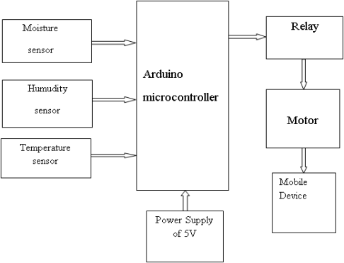

# Fig1: Block Diagram of Automatic Irrigation System

Figure shows the block diagram of smart irrigation system with IoT. Farmers start to utilize various monitoring and controlled system in order to increase the yield with help of automation of an agricultural parameters like temperature, humidity and soil moisture are monitored and control the system which can help the farmers to improve the yield. This proposed work includes an embedded system for automatic control of irrigation. This project has wireless sensor network for real-time sensing of an irrigation system. This system provides uniform and required level of water for the agricultural farm and it avoids water wastage. When the moisture level in the soil reaches below threshold value then system automatically switch ON the motor. When the water level reaches normal level the motor automatically switch OFF. The sensed parameters and current status of the motor will be displayed on user’s android application.

* 1. **OBJECTIVE OF THE PROJECT**

The main objective of this project is to provide an automatic irrigation system there by saving time, money & power of the farmer. The traditional farm-land irrigation techniques require manual intervention. With the automated technology of irrigation the human intervention can be minimized.

**DESIGN**

Design of a system explains temperature, humidity and soil moisture values using flow chart.

**FLOW CHART**

A flowchart is a graphic representation of a logic sequence, work or manufacturing process, organization chart, or similar formalized structure. The flowchart is a means to visually present the flow of data through an information processing system.

**TEMPERATURE AND HUMIDITY SENSOR**

This below Figure shows the sensed values of temperature and humidity.

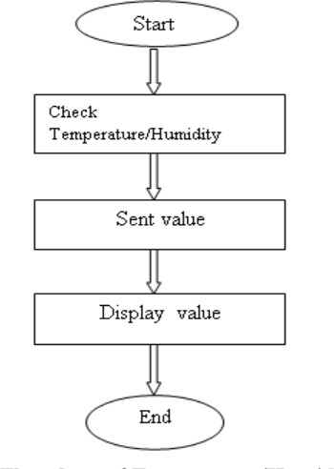

# Fig2: Flowchart of Temperature/Humidity Sensor

The DHT11 is a basic, digital temperature and humidity sensor. It uses a capacitive humidity sensor and a thermistor to measure the surrounding air, and spits out a digital signal on the data pin (no analog pins needed). It is simple to use, but requires careful timing to grab data. Humidity sensors are used for measuring moisture content in the atmosphere. Then current temperature, humidity values are sent to the microcontroller, those values will display in the users android app.

**SOIL MOISTURE SENSOR**

This below Figure shows the procedure of displaying soil moisture value.

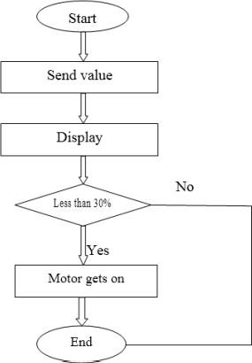

# Fig3: Flow chart of Soil moisture sensor

Soil moisture sensors measure the water content in the soil. Moisture in the soil is an important component of the atmospheric water cycle. The sensor module outputs a high level of resistance when the soil moisture is low. It has both digital and analog outputs. The digital output is simple to use, but it is not as accurate as analog output based on moisture level motor gets turn on/off automatically.

* 1. **Components required for Automatic Irrigation System**

The project requires very few components and the connection is also very simple. The components are listed below:

* Arduino * 1
* moisture sensor * 1
* Temperature Sensor
* 5v relay module * 1
* 6v Mini water pump with small pipe * 1
* Connecting wires
* 5v battery * 1

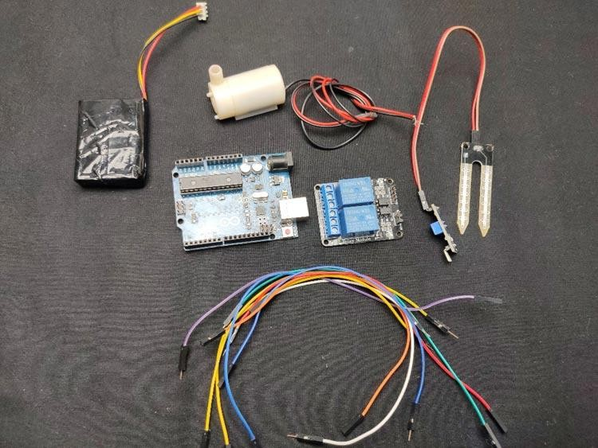

# Fig4: Components required for Automatic Irrigation System

The logic of this system is very simple. In this system, the moisture sensor senses the moisture level of the soil and when the sensor senses a low moisture level it automatically switches the water pump with the help of a microcontroller and irrigates the plant. After supplying sufficient water, the soil gets retains the moisture hence automatically stopping the pump.

**Soil Moisture Sensor**

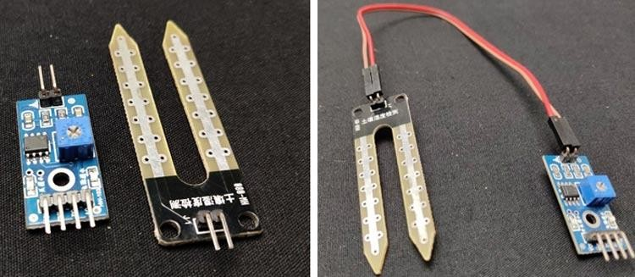

# Fig5: Soil Moisture Sensor

The working of the soil moisture sensor is very easy to understand. It has 2 probes with exposed contacts that act like a **variable resistor** whose **resistance varies** according to the water content in the soil. This resistance is inversely proportional to the soil moisture which means that higher water

in the soil means better conductivity and hence a lower resistance. While the lower water in the soil means poor conductivity and will result in higher resistance. The sensor produces an analog voltage output according to the resistance.

The sensor comes with an electronic module that connects the probe to the Arduino. The module has an **LM393 High Precision Comparator** which converts the analog signal to a Digital Output which is fed to the microcontroller. We have covered an in-depth [Arduino soil moisture sensor](https://circuitdigest.com/microcontroller-projects/interfacing-soil-moisture-sensor-with-arduino-uno) tutorial which covers the working of soil moisture sensor module and how to use it with the Arduino. You can check the tutorial if you want to learn more about the soil moisture sensor.

**Pump**

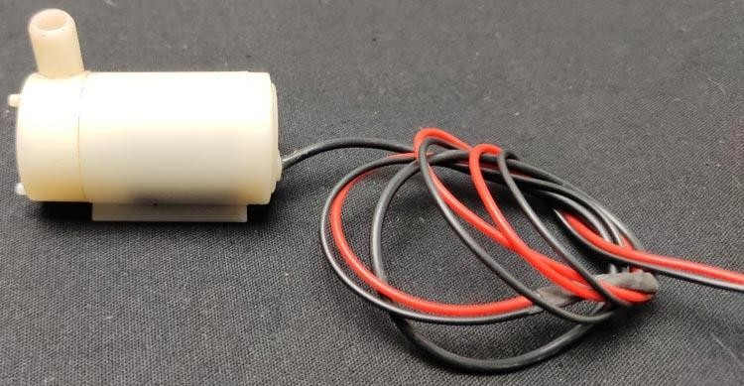

# Fig6: Motor Pump

We need a small pump to irrigate the plant, but in the case of a garden, we need to drive a larger pump that can provide a higher volume of water depending on the size of your garden which can’t be directly powered by an Arduino. So in case you need to operate a larger pump, a driver is necessary to provide enough current for the pump, to show that I am using a 5v relay. You can also use an AC-powered pump and use a suitable relay. The working will remain the same as shown in this project, you just have to replace the DC power input connected to the relay with an AC power input and have to power your Arduino with a separate DC power source.

**5V Battery**

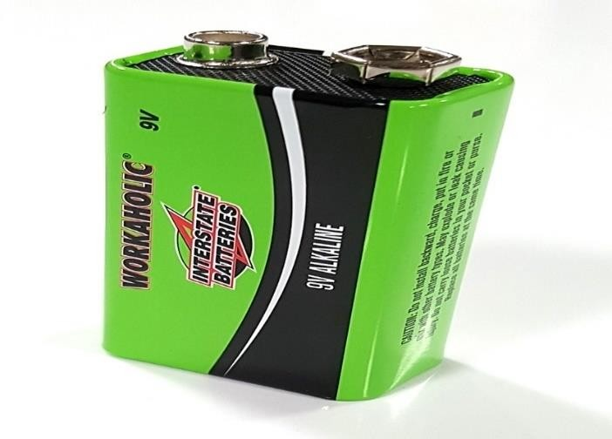

# Fig7: 5V Battery

An **electric battery** is a source of [electric power](https://en.wikipedia.org/wiki/Electric_power) consisting of one or more [electrochemical cells](https://en.wikipedia.org/wiki/Electrochemical_cell) with external connections for powering [electrical](https://en.wikipedia.org/wiki/Electricity) devices.

When a battery is supplying power, its positive terminal is the [cathode](https://en.wikipedia.org/wiki/Cathode) and its negative terminal is the [anode.](https://en.wikipedia.org/wiki/Anode) The terminal marked negative is the source of electrons that will flow through an external electric circuit to the positive terminal. When a battery is connected to an external electric load, a [redox](https://en.wikipedia.org/wiki/Redox) reaction converts high-energy reactants to lower-energy products, and the [free-](https://en.wikipedia.org/wiki/Gibbs_free_energy) [energy](https://en.wikipedia.org/wiki/Gibbs_free_energy) difference is delivered to the external circuit as electrical energy. Historically the term "battery" specifically referred to a device composed of multiple cells; however, the usage has evolved to include devices composed of a single cell.

**5V Relay Module**

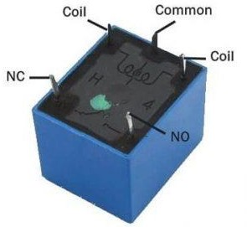

# Fig8: 5V Relay Module

Relay is one kind of [electro-mechanical component](https://www.elprocus.com/electromechanical-relay-working-with-applications/) that functions as a switch. The relay coil is energized by DC so that contact switches can be opened or closed. A single channel 5V relay module generally includes a coil, and two contacts like normally open (NO) and normally closed (NC). This article discusses an overview of the 5V relay module & its working but before going to discuss what is [relay](https://www.elprocus.com/relay-circuit-with-working/) module is, first we have to know what is relay and its pin configuration. A 5v relay is an automatic [switch](https://www.elprocus.com/what-is-a-centrifugal-switch-and-its-working/) that is commonly used in an automatic control circuit and to control a high-current using a low-current signal. The input voltage of the relay signal ranges from 0 to 5V.

**Temperature Sensor (LM35)**

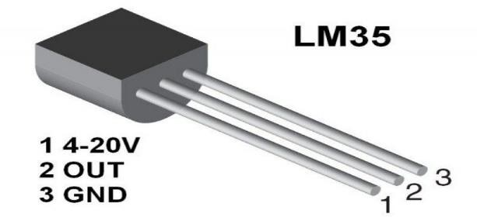

# Fig9:LM35 Temperature Sensor

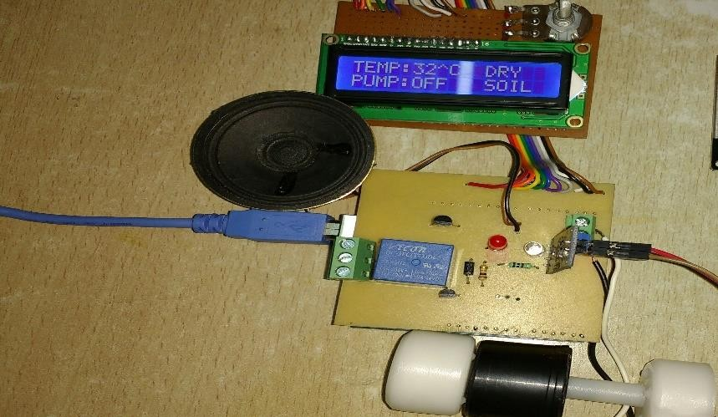

# Fig10: Temperature Display

Temperature sensor senses the temperature from the various range of physical body. It is one of the main thing had often calculated. The sensing of the temperature using temperature sensor is done by two ways either by direct or indirect method. The direct method is done by made a contact with the source and the indirect method is done without contacting the source body instead of that using radiated energy of the source. In this project, we are using DHT11 which is the temperature sensor. It consists of four pins, the first pins is used for the voltage supply, the second pin is used as the output pin, the third pin is considered as NULL pin and the last pin is used for the ground supply.

The LM35 is a precision IC temperature sensor with its output proportional to the temperature (in o C). The sensor circuitry is sealed and therefore it is not subjected to oxidation and other processes. With LM35, temperature can be measured more accurately than with a thermistor. It also possess low self heating and does not cause more than 0.1 o C temperature rise in still air. The operating temperature range is from -55°C to 150°C. The output voltage varies by 10mV in response to every o C rise/fall in ambient temperature, i.e., its scale factor is 0.01V/ o C.

* 1. **Circuit Diagram of the Arduino Automatic irrigation system**

The complete circuit diagram for the Arduino Automatic irrigation system is shown below:

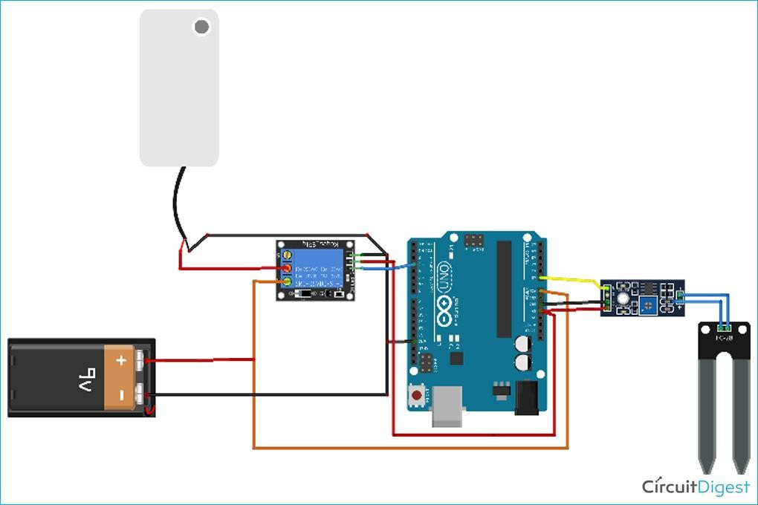

Fig 11: Circuit diagram of Arduino Automatic Irrigation System

In this section, I will explain all the details with the help of the schematic diagram. The **Arduino UNO** is the brain of this whole project. It controls the motor pump according to the moisture in the soil which is given by the moisture sensor.

To power the circuit, I am using an external Battery. You can use any 9v or 12-volt battery. The battery is connected to the Vin and ground pins of Arduino and we can also connect the motor to this battery via a relay. Moisture sensor output is connected to the analog pin of Arduino. Do remember to use the Arduino’s 5volt pin to power the sensor and relay module.

* 1. **Assembling the Automatic Irrigation System**

Let's start with connecting the relay to the Arduino board. Connect the VCC of the relay module to the 5v pin of the Arduino and connect the ground of the relay to the ground of Arduino.

Now connect the relay signal pin to any digital pin of Arduino except pin 13. Here I have connected it to pin 3 as shown in the image below.

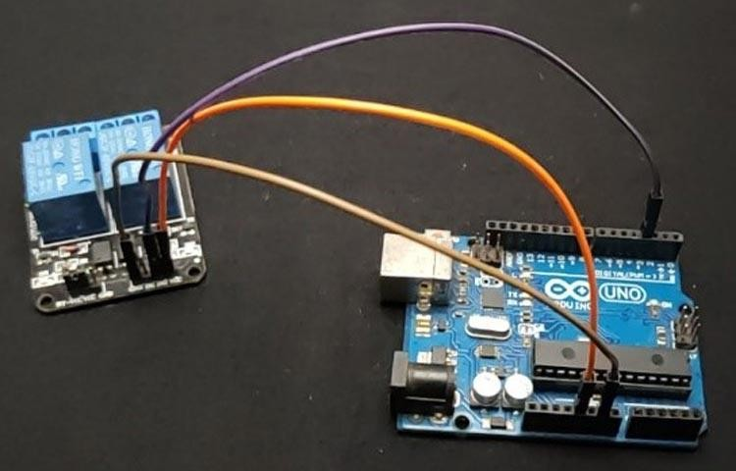

Fig 12: Assembling the wires in Automatic Irrigation System

The next step is to connect the soil moisture sensor with the Arduino. Connect the VCC and gnd of the sensor to the 5volt and ground pin of the Arduino. The analogue output of the sensor connects to any analogue pin of the Arduino, here I’ve connected it to pin A0 (according to our program).

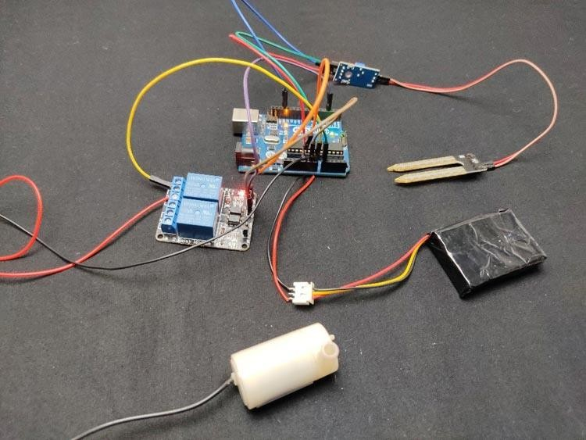

Fig 13: Assembling the whole Automatic Irrigation System Components

Finally, connect the pump to the relay module. A relay module has 3 connection points which are common, normally closed, and normally open. We have to connect the pump positive to common and connect the normally open pin to the positive of the battery. You have to select the battery as per your pump. The next step is to connect the ground of the pump to the ground of the Arduino and finally, connect the small hose to the water pump.

Now connect the battery to the circuit and if the pump starts working then your circuit is okay. Now let's upload code to Arduino.

So In this project the arduino Microcontroller is used and soil moisture sensor are used to determine moisture level of the soil. The relay module are used to control the pump connected across it. As moisture sensor value goes below the 400 the arduino turn ON the pump and after some time when moisture sensor sense value goes above the 400 the pump get automatically OFF. I provide PCB layout where you can easily construct the PCB of this project. You can simply print the PCB layout and using toner transfer technique you can make PCB. Drill the PCB and place all components on board then solder it properly. Place the moisture sensor in pot, I connected the small submersible pump you can connect other pumps available in market. The pump was deep in the water which supply the water to the plants.

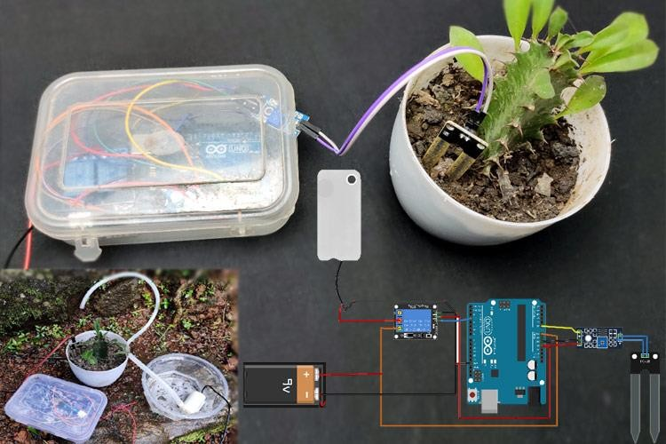

# Fig 14: Automatic Irrigation System using an Arduino Uno

**CHAPTER 2: IMPLEMENTATION AND ARCHITECTURE**

## AN AUTOMATED IRRIGATION HARDWARE IMPLEMENTATION

This project design includes several functional blocks as shown Figure 1.1, namely: acquisition block, microcontroller block, automatic functional block and monitoring block.

* **Acquisition block**

This block consists of one soil moisture sensor which takes the data from the soil. It depends on the moisture level of the soil whether to send high or low voltage to the microcontroller to show that it is wet or dry. When the soil is wet, it will send the low output voltage, whereas when it is dry, it will send the high output voltage. This sensor is directly connected to Arduino microcontroller.

* **Microcontroller block**

In this block, Arduino Uno is the microcontroller which is the core hardware of this project. It receives the input from the soil moisture sensor and processes the input based on the requirement coded in the microcontroller.

* **Monitoring block**

This block includes an LCD display, which is used to monitor the level of soil moisture by showing the percentage of the moisture on the screen. When the soil is dry the percentage will be lower and vice versa. In addition, it also shows the pump status which is on or off, in which users will know the current pump status.

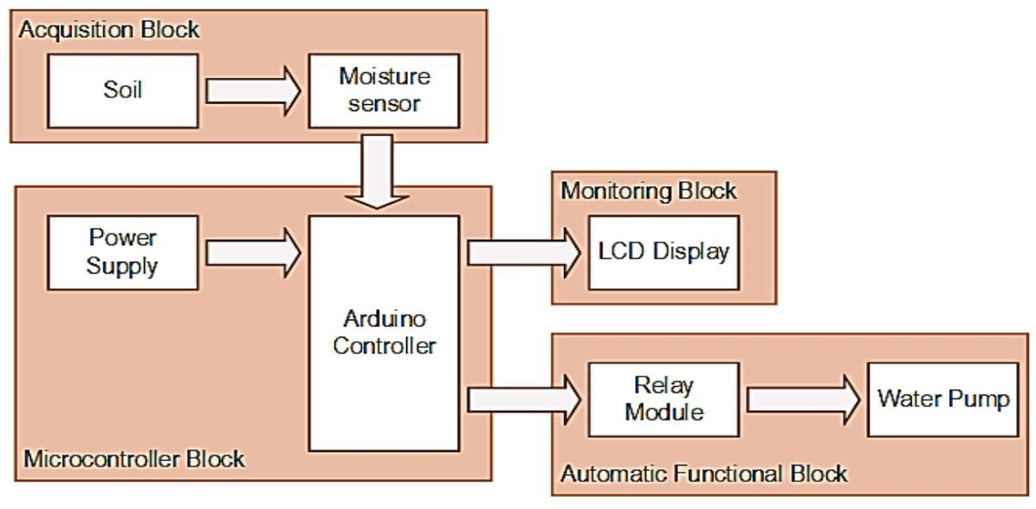

# Fig15 : Functional Block Diagram

* **Automatic Functional block**

This block includes the automated watering function of the system. The automated function consists of two main controlling hardware, which is relay module and DC watering pump. The relay is an automatic electric switch that uses an electromagnet to move the switch from OFF to ON or vice versa. The switch controls the electric signal that pass through the water pump. When the moisture level is below the threshold level, Arduino sends a signal to the relay module to automatically open the path for the electric to pass through the water pump to water the plant. After the system detects the sufficient level of the water in the soil, the relay will close the path for electric and thus the water pump will be stop immediately pumping the water.

An Automated Irrigation System Using Arduino Microcontroller All the hardware will be assembled to Arduino, which is the microcontroller that use to control all the hardware that attached to it and let it function. Figure 1.2 shows the details of Arduino pins and their connection to the corresponding hardware, which are based on the table.

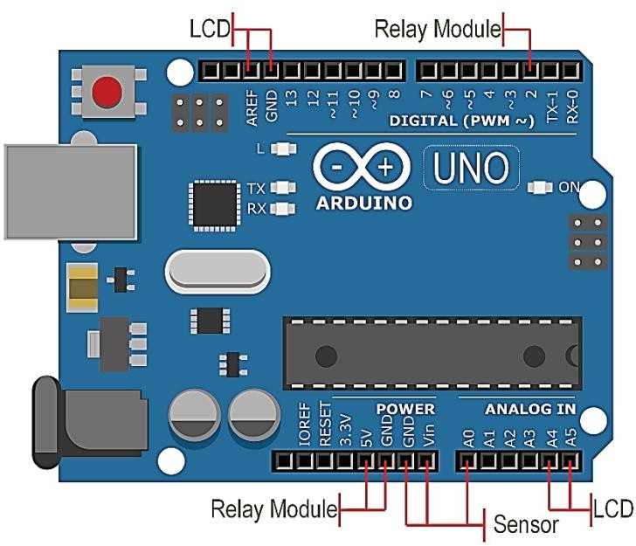

# Fig16: Details of Arduino Pin for Hardware Connection

The Uno is a microcontroller board based on the ATmega328P. It has 14 digital input/output pins (of which 6 can be used as PWM outputs), 6 analog inputs, a 16 MHz quartz crystal, a USB connection, a power jack, an ICSP header and a reset button. Each of the 14 digital pins can be used as an input or output, using pin Mode (), digital Write (), and digital Read () functions. They operate at 5 volts. Each pin can provide or receive 20 mA as recommended operating condition and has an internal pull-up resistor (disconnected by default) of 20-50k ohm. A maximum of 40mA is the value that must not be exceeded on any I/O pin to avoid permanent damage to the microcontroller.

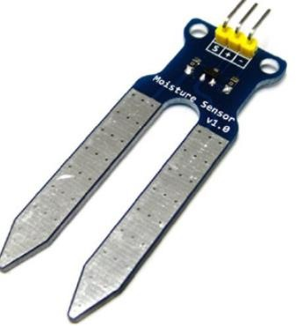

# Fig17: Soil Moisture Sensor

The Soil moisture sensor unit consists of soil moisture sensor and LM393 comparator chip. The soil moisture sensor is used to detect the soil moisture. The soil probe is dip in to the soil such that when the soil moisture is LOW the module output is HIGH indicated by using RED led on the comparator chip. This sensor measures the dielectric constant of the soil by using

transmission line techniques. This circuit consists of four pins such as power supply pin, ground pin, analog and digital pins.The analog pin A0 connected to the analog pin of ARDUINO board and digital D0 pin connected to the digital pin of ARDUINO board. This sensor is a dual output mode in which analog output is more accurate.

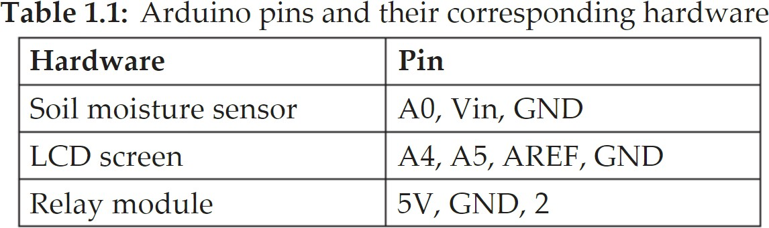

Figure shows the complete hardware setup of the proposed system which include the Arduino board and all the necessary attached hardware. This project is considered a complete prototype where it can be used and function for the daily life. From Figure 1.3, it can be seen that the Arduino is the centre of this system which the connects all required hardware. The soil moisture sensor measures the level of moisture from the soil, and it is transferred to the Arduino board to process and make decision.

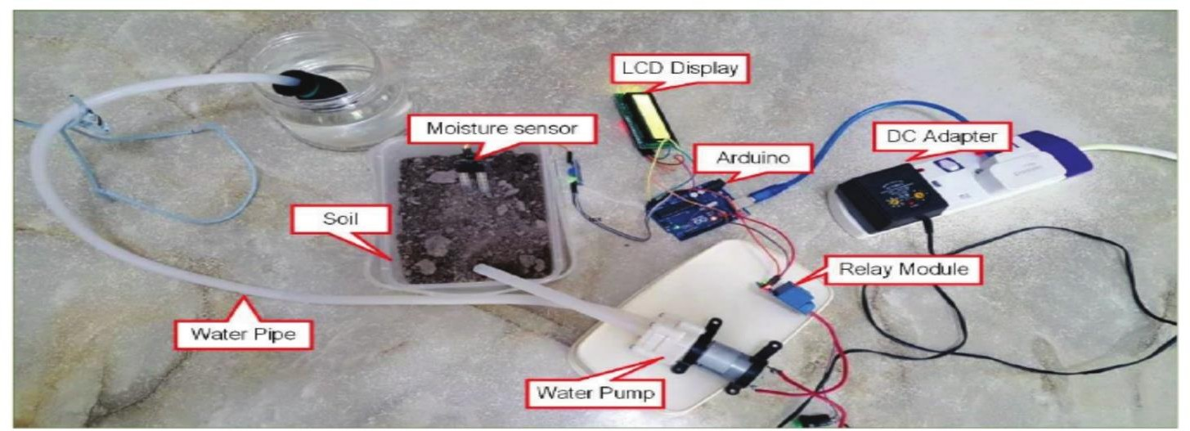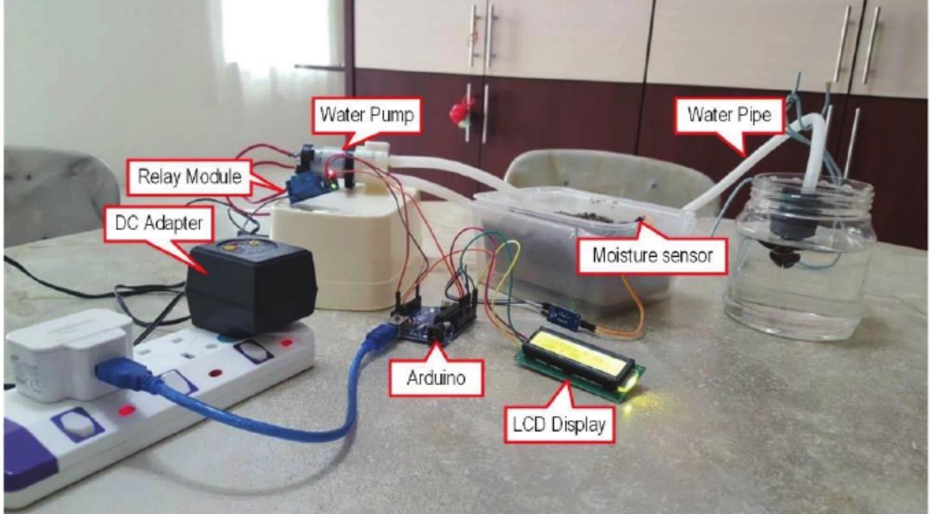

Fig18: Hardware implementation for the whole project (Top and side view)

The LCD display shows the value that the Arduino received from the moisture sensor. At the same time, the data acquired is sent to relay module to determine whether to switch on or off the water pump.

If the condition is met for the water pump to be switched on, the water pipe attached to the pump will begin to draw up the water from the water source, and push the water to the other side of water pipe to complete the watering process for the soil.

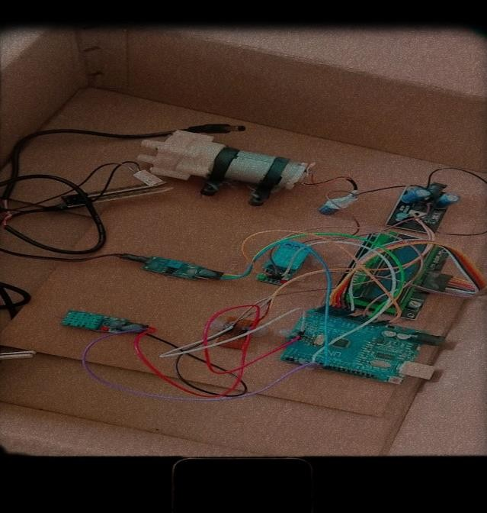

# Fig19: Detailed Arduino Kit

* 1. **: PROTOTYPE**

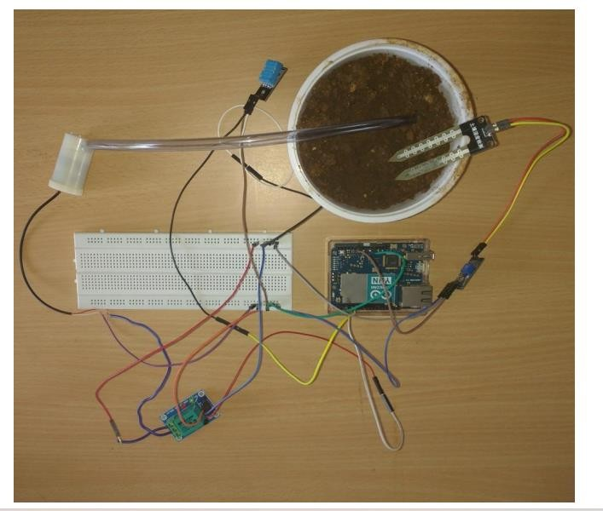

# Fig20: Prototype of Automatic Irrigation System

Figure 8 shows the prototype of automatic irrigation system. The microcontroller Arduino is connected to temperature sensor, soil moisture sensor, humidity sensor, relay and motor. These sensors sense the various parameter of the soil, the motor is used to provide water to the land. And relay is used control the motor.

Irrigation forms one of the primary components of agriculture and food production. Due to outdated techniques in developing and underdeveloped countries, a huge volume of water is wasted in this process. In this article, we have devised a fuzzy rule-base irrigation controller prototype to put a check on this water wastage by providing an optimal irrigating environment for farming. The prototype smart automatic irrigation controller (SAIC) has two operational units, namely, wireless sensor unit (WSU) and wireless information processing unit (WIPU).

The purpose of the WSU is to measure weather and soil conditions and calculate the actual water loss due to evapotranspiration. The WIPU processes this calculated value and performs the necessary control action to regulate the actuators supplying the right amount of water to the farm. An exhaustive rule-base combination model is stacked in the lookup table for decision making. The prototype model is first simulated and then validated in the field for checking the performance efficiency.

* 1. **Applications**

Some of the applications of the project are listed below:

It can be used to measure the loss of moisture in the soil over time due to evaporation and intake. Minimizes water waste and improves plant growth and the circuit is designed to work automatically and hence, there is no need for very less human intervention .

The same system or in general the same idea can be used along with sensors of temperature (DHT11 or LM35), solar exposure, pH value and mineral content of the soil in the field for example in fertilizer spraying for plants: the use of sensors which measure the number of different minerals in the soils will indicate which are deficient in the soil such as magnesium.

It can be implemented in the process of spraying of pesticides.

**CHAPTER 3: PROPOSED ALGORITHM**

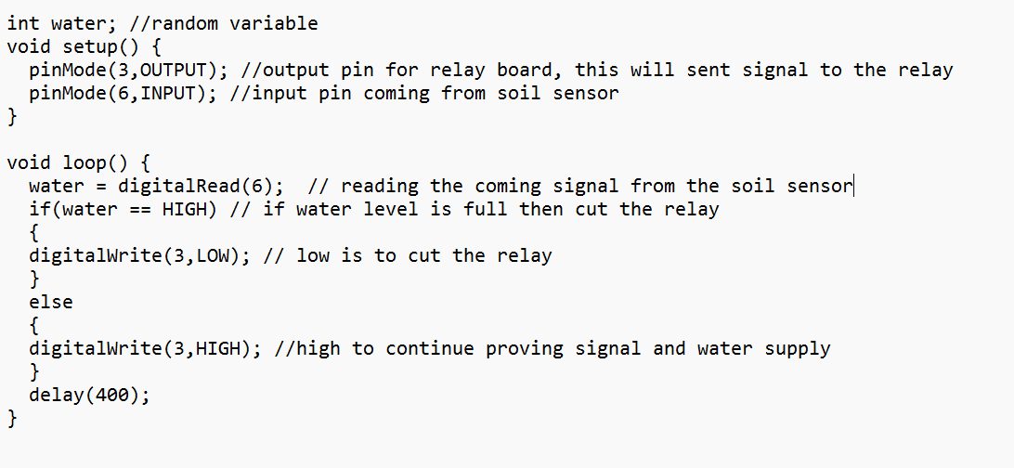

**3.2 SOIL MOISTURE SENSOR TEST**

This section describes the test strategy that is used for this project. The test is used to determine whether the hardware and software will be test early to make sure that it is functioning according to the requirement (refer Table 1.2).

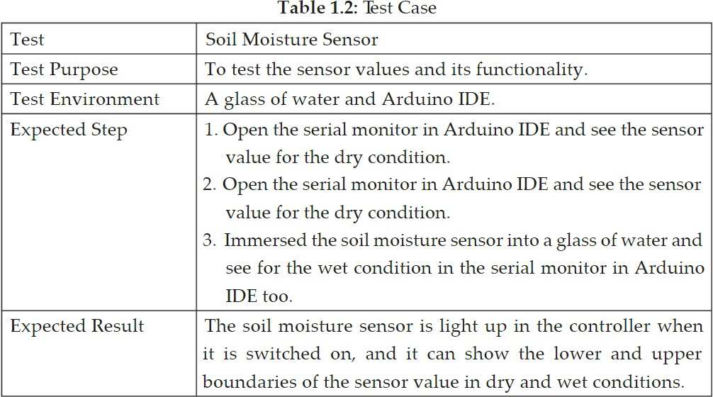

From the Figures 1.6 and 1.8, the test shows that the soil moisture sensor captures high values for dry condition which are around 893 with 900 as the upper boundary.

From the Figures 1.7 and 1.9, the test shows that the soil moisture sensor capture low values for wet condition which are around 399 with 400 as the lower boundary.

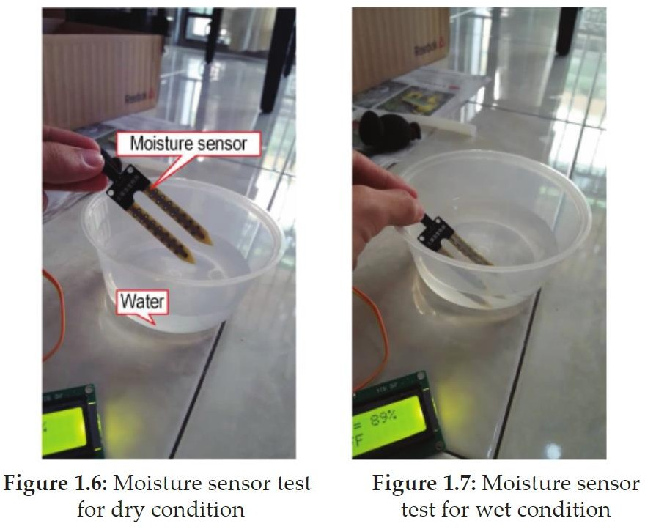

With the advancement of automation technology, life is getting simpler and easier in all aspects. In today’s world Automatic systems are being preferred over manual system. Automatic system is a growing system of everyday object from industrial machine to consumer goods that can complete tasks while you are busy with other activities. India's population is reached beyond 1.2 billion and the population rate is increasing day by day then after 25-30 years there will be serious problem of food, so the development of agriculture is necessary. Today, the farmers are suffering from the lack of rains and scarcity of water.

The main objective of this paper is to provide an automatic irrigation system thereby saving time, money & power of the farmer. The traditional farmland irrigation techniques require manual intervention. With the automated technology of irrigation the human intervention can be minimized. Whenever there is a change in temperature and humidity of the surroundings these sensors senses the change in temperature and humidity and gives an interrupt signal to the micro-controller.

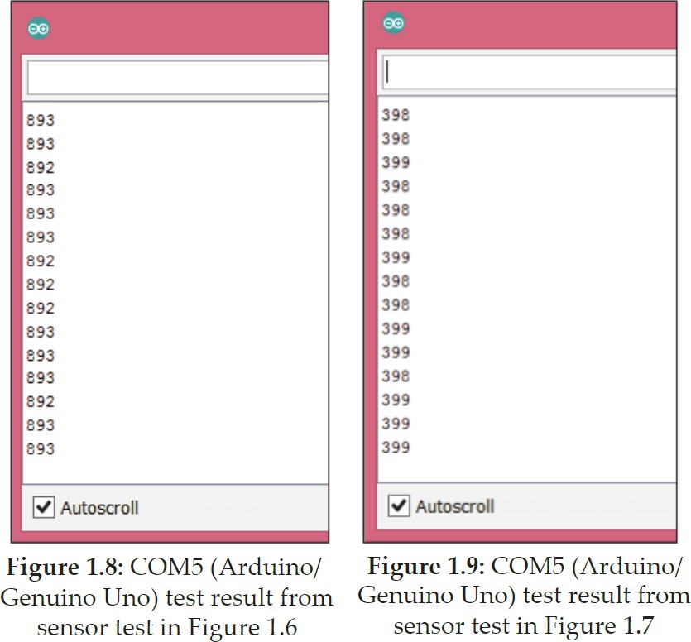

We have successfully designed and implemented a smart irrigation system using the concept of the Internet of Things. This automated irrigation system is easily controlled using a computer. It behaves as an intelligent switching system that detects the soil moisture level and irrigates the plant if necessary. This will also save time and energy, as well as minimize energy loss. With the use of sensors whose cost is low and with simple circuitry, this experiment aims in a low-cost solution, which can be bought even by a poor farmer and it is also easy to implement.

**CHAPTER 4 CONCLUSION**

The application of agriculture networking technology is need of the modern agricultural

development, but also an important symbol of the future level of agricultural development; it will be the future direction of agricultural development. After building the agricultural water irrigation system hardware and analyzing researching the network hierarchy and features, functionality and the corresponding software architecture of precision agriculture water irrigation systems, actually applying the internet of things to the highly effective and safe agricultural production has a significant impact on ensuring the efficient use of water resources as well as ensuring the efficiency and stability of the agricultural production. With more advancement in the field of IoT expected in the coming years, these systems can be more efficient, much faster and less costlier. In the Future, this system can be made as an intelligent system, where in the system predicts user actions, rainfall pattern, time to harvest, animal intruder in the field and communicating the information through advanced technology like IoMT can be implemented so that agricultural system can be made independent of human operation and in turn quality and huge quantity yield can be obtained.

**REFERENCES**

1. Anurag D, Sauli Roy and Somprakash Bandyopadhyay, “Agro-Sense: Precision Agriculture using Sensor-based Wireless Mesh Networks”, ITU-T “Innovation in NGN”, Kaleidoscope Conference, Geneva 12-13 May 2008.
2. C. Arun, K. Lakshmi Sudha “Agricultural Management using Wireless Sensor Networks – A Survey”2nd International Conference on Environment Science and Biotechnology IPCBEE vol.48 (2012) © (2012) IACSIT Press, Singapore 2012.
3. Bogena H R, Huisman J A, OberdErster C, etal. Evaluation of a low cost soil water content sensor for wireless network applications [J].Journal of Hydrology, 2007.
4. R. Hussain, J. Sehgal, A. Gangwar, M “. Riyag Control of irrigation automatically by using wireless sensor network” International journal of soft computing and engineering, vol.3, issue 1, march 2013.
5. Izzatdin Abdul Aziz, MohdHilmiHasan, Mohd Jimmy Ismail, MazlinaMehat, NazleeniSamihaHaron, “Remote Monitoring in Agricultural Greenhouse Using Wireless Sensor and Short Message Service (SMS)”, 2008.
6. Jeonghwan Hwang, Changsun Shin, and Hyun Yoe “Study on an Agricultural Environment Monitoring Server System using Wireless Sensor Networks”, 2010.
7. Ning Wang, Naiqian Zhang, Maohua Wang, “Wireless sensors in agriculture and food industry— Recent development and future perspective”, published in Computers and Electronics in Agriculture 2006.
8. Pepper Agro, “M-Drip Kit” Internet: [www.pepperagro.i/mdripkitmanual.htmlSiuliRoy,](http://www.pepperagro.i/mdripkitmanual.htmlSiuliRoy) SomprakashBandyopadhyay, “A Test-bed on Real-time Monitoring of Agricultural Parameters using Wireless Sensor Networks for Precision Agriculture” 2007.
9. Yiming Zhou, Xianglong Yang, Liren Wang, Yibin Ying, A wireless design of low-cost irrigation system using ZigBee technology, International Conference on Networks Security, Wireless Communications and Trusted Computing , IEEE 2009.
10. Zhang xihai, Zhang changli Fang junlong. Smart Sensor Nodes for Wireless Soil Temperature Monitoring Systems in Precision Agriculture 2009.
11. R. Suresh, S. Gopinath, K. Govindaraju, T. Devika, RainguniraVaSuthanthnitha “GSM based Automated Irrigation Control using Irrigation System”, International Journal of Advanced Research in Computer and Communication Engineering Vol. 3, Issue 2, February 2014.
12. Pavithra D. S, M. S .Srinath, “GSM based Automatic Irrigation Control System for Efficient Use of Resources and Crop Planning by Using an Android Mobile”, IOSR Journal of Mechanical and Civil Engineering (IOSR-JMCE) Vol 11, Issue I, Jul-Aug 2014, pp 49-55.